Protein in 100 calories of food

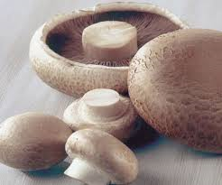Mushrooms 15 grams | 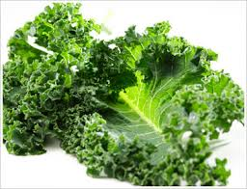Kale 8 grams | 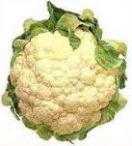Cauliflower 8 grams
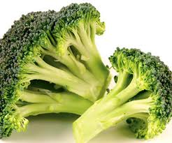Broccoli 7 grams | 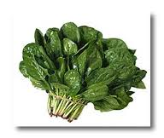Spinach 6 grams | 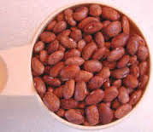Beans 6 grams
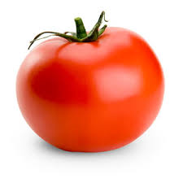Tomato 5 grams | 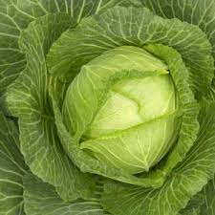Cabbage 5 grams | 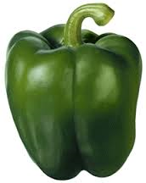Bell Pepper 4 grams
Cheddar cheese has 6 grams & 26 mg of cholesterol. 1 oz has 113 calories & is the size of a dice. | Ground hamburger has 9 grams & 32 mg of cholesterol (1.3 oz of hamburger=100 calories) | 100 calories of egg has 8 grams & 259 mg cholesterol
Plants have no cholesterol. Livers make cholesterol so only meat, eggs and dairy contain cholesterol. 3oz of meat is the size of a deck of cards.

