Po boy61
24 oz extra firm tofu , drained and pressed 1/2 cup unsweetened almond milk if needed 1 cup corn meal 1/4 cup flour 2-1/2 tsp cajun seasoning or Old Bay seasoning 1 tsp ground black pepper 1 tsp garlic powder 1 tsp onion powder 1/4 tsp cayenne 1 loaf of french bread to make the sandwich | 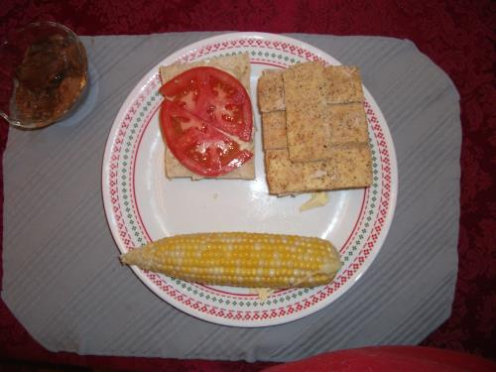
Could be faux fish for another recipe. Calorie count does not include bread or toppings or tofu. This makes 2, 3/4 cup servings and 3/4 c is needed for 12 oz. 3/4 c is 360 calories and will do 17 slices. If 12 oz is sliced into 17 slices, then 4.25 slices=74 calories. and 4.25 of 360 calories is 85 calories. So 4.25 slices of tofu breaded should be 74+85=159
Procedure
    - To “dress” your po boy gather your favorite toppings: lettuce tomato eggless mayo pickles eggless tartar sauce mustard
    - Slice the tofu block into 7 or 8 slices, lengthwise (thinner for those who do not like the soft texture of tofu).
    - IF your tofu is dry and the coating won't stick then using a medium bowl add some of the almond milk for dipping before breading.
    - Combine the cornmeal & spices and stir to combine. Place some cornmeal mix on a plate to bread the tofu. I sprinkle Old Bay on top of the cornmeal before every slice to ensure lots of Old Bay on every slice. If you need to dip, then dip each tofu slice into the almond milk and then onto the seasoned cornmeal mixture and cover all sides completely.
    - “Fry”/bake pieces in skillet for about 4 minutes on each side. They should be a golden color. Or bake at 350 degrees for 15 minutes and flip and cook another 10 minutes. Serve on warmed french bread dressed as desired
Servings: 2
Yield: 4 oz per serving-By slicing tofu thin they crisp/firm better.
Nutrition Facts
Nutrition (per serving): 360 calories, 14 calories from fat, 1.6g total fat, 0mg cholesterol, 7.9mg sodium, 177mg potassium, 77.2g carbohydrates, 4.1g fiber, 1.5g sugar, 7.7g protein.

