Kristyn’s Vegetable Chili
2 zucchini 1 cup onions, diced 2 red peppers diced 3 cans 14 oz diced tomatoes 1 ½ cup kidney beans 1 ½ cup chickpeas 4 cloves minced garlic 3 Tbs chili powder 2 Tbs lemon juice 2 Tbs cumin 2 Tbs oregano 2 Tbs basil 1 Tbs pepper 1/2 tsp fennel seed, crushed ½ cup fresh chopped Italian parsley (optional) | 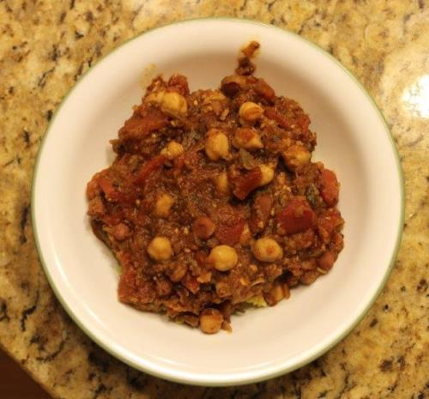
Procedure
    - Can use 1 1/2 cups homemade cooked beans or a 15 oz can is a heaping 1 1/2 cup. For canned, drain and rinse beans.
    - Crockpot method: Put all ingredients except garlic and spices in crockpot and cook until warm-4-8 hours. Can add spices with other ingredients but for optimal flavor it is best to reserve garlic and spices and add them an hour before serving.
    - Stove top method: In a large soup pot sauté zucchini (about 7 minutes) then add onions, garlic and red peppers and sauté. Place the pot on low heat. Add the remaining ingredients other than the beans. Cook, uncovered, stirring often for 30 minutes. Stir in the kidney beans and chick-peas and cook another 15 minutes.
Servings: 6 Yield: abt 1 cup heaping servings
Nutrition Facts
Nutrition (per serving): 231 calories, 32 calories from fat, 3g total fat, 0mg cholesterol, 254.1mg sodium, 778.1mg potassium, 31.7g carbohydrates, 12.8g fiber, 14.2g sugar, 10g protein.

