BBQ & Bean Biscuit Casserole
Hiding broccoli in this not only makes it a one pot meal with no need of a side, it reduces the calorie count of the dish, too! Quick, inexpensive, kids like it!!
If you use TVP, make 1/2 c into 1 cup of crumbles and stir 1/2 c dry TVP into beans to soak up sauce.
1 recipe faux hamburger crumbles (2c) 1 onion 1 1/2 cup broccoli 3 cups Navy beans, cooked 1/4 cup brown sugar 3 Tbs Splenda 2 Tbs vinegar (white) 1 Tbs Worcestershire sauce 1/2 tsp salt 1/4 tsp black pepper 8 oz tomato sauce 1 1/2 tsp liquid smoke 3/4 tsp cinnamon 1/4 tsp garlic powder 1/4 tsp onion powder 1/2 tsp celery seed 1 dash cloves 21/4 cups bisquick 2/3 cup non-dairy milk | 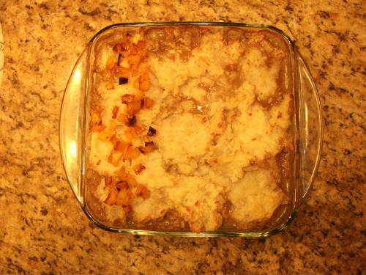
Procedure
    - Can use homemade cooked beans or a 15 oz can is a heaping 1 1/2 cup. For canned, drain and rinse beans.
    - Mince onion and sauté.
    - Mince broccoli in food processor, too (so kids do not detect it!) (So can use less expensive broccoli stems and save the flowers for a side dish).
    - Make biscuit top with bisqick and non dairy milk.
    - Mix all ingredients other than the biscuit top and put in an 8" x8 " (2 quart) baking dish. Top with the biscuit dough.
    - Cook for 10-15 minutes until biscuit is cooked.
Servings: 9
Oven Temperature: 350°F
Nutrition Facts
Serving size: 1/9 of a recipe (5.3 ounces). | 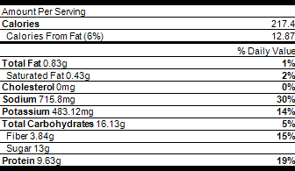
Source
Source: http://vegweb.com/recipes/bbq-beef-and-bean-biscuit-bake#sthash.0fJQDMh5.dpuf

