Tostada Bake
TVP taco filling is simply faux hamburger crumbles with taco seasoning added to taste. This recipe uses homemade crumbles but could use store bought frozen product, too.
2 cup Bisquick ½ cup cornmeal ½ cup nondairy milk 3 Tbs applesauce 2 cup TVP taco filling 8 oz tomato sauce 16 oz no-fat refried beans ½ cup chopped onion, sauteed (optional) Tostada toppings like chopped lettuce and tomato and onion as desired | 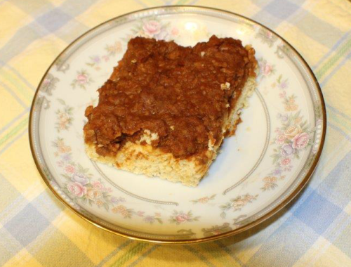
Procedure
    - Tostada: Mix Bisquick, cornmeal, applesauce and non-dairy milk just until ingredients mixed. Pat dough into a 9” x 13” sprayed pan and cook for 9-10 minutes.
    - Mix remaining ingredients in a sauce pan over low to medium heat until thoroughly mixed. Pour/spread over cooked tostada. Bake 10-15 min until hot. Top with desired tostada toppings.
Servings: 9
Degree of Difficulty: Very easy
Oven Temperature: 350°F
Nutrition Facts
Serving size: 1/9 of a recipe (6 ounces). | 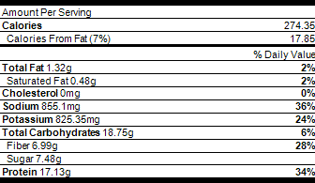
Recipe Type
Main Dish, Vegan - Plant Based

z Faux hamburger crumbles
1 Tbs soy sauce  1 Tbs Worcestershire sauce  1 Tbs steak sauce  ¼ tsp onion powder | ¼ tsp garlic powder  ¼ tsp ginger  1 cup dry TVP
Procedure
    - Mix all ingredients except TVP together with 1 c water until well combined. Bring to a boil then add TVP and remove from heat. Stir well.
    - If in a pinch for time, just microwave all ingredients in the water and add TVP. Will also reconstitute in cold water, it just takes a little longer.
Servings: 2
Yield: Once reconstituted makes about 2, 1 cup servings
Degree of Difficulty: Very easy
Nutrition Facts
Serving size: 1/2 of a recipe (2.8 ounces). | 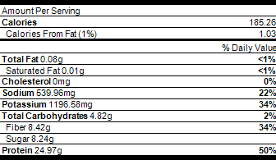
Recipe Type
Main Dish, Vegan - Plant Based
Recipe Tips
(TVP is dry tofu. It can be bought in small bags in the health food/bulk area of most grocery stores or in bags sold by Bob's Red Mill or in bulk online is cheapest at bulkfoods.com)

